TC_01_Validate CMM xml for following field as per mapping V1.12.1

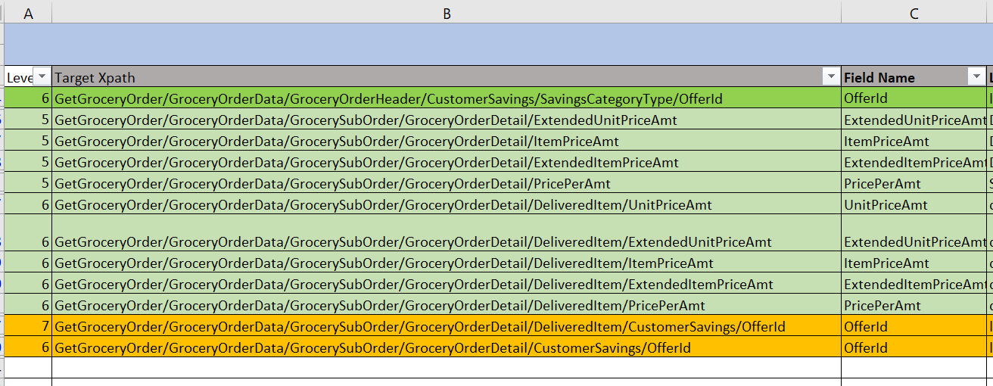

And highlighted in orange one validate with following –



Test Result:Pass

JSON Message(OMS source)-

{"_id":"5fe41c75019f65001088d0a7S","version":4,"modifiedBy":"OSCO-Processor","modifiedDate":"2020-12-23T20:57:38.722-08:00","ttl":-1,"orderNumber":"20064781","versionNumber":1,"orderStatus":"PAYMENT_REQUESTED","companyId":"1","banner":"carrsqc","isActive":true,"storeNumber":"1739","modifiedReasonCode":"PAYMENT_REQUESTED","orderEditCutoffDate":"2020-12-23T13:00:00.000-08:00","orderCreatedDate":"2020-12-23T20:43:33.351-08:00","fulfillmentSystem":"MANHATTAN","sourceInfo":{"source":"ECOMMERCE","enteredBy":"CUSTOMER","deviceType":"WEB"},"orderTotal":{"amount":"33.98","currency":"USD","txnLevelSavings":[]},"customer":{"customerId":"557-252-1597275418806","clubCardNumber":"49372835334","isSubscription":true,"name":{"firstName":"Prameela","lastName":"Medarametla"},"address":[{"addressType":"SHIPTO","addressLine1":"664 W Evergreen Ave","city":"Palmer","state":"AK","zipCode":"99645","country":"USA"}],"contact":[{"number":"5109962550","type":"MOBILE"}],"email":[{"_id":"rani.dulipalla@gmail.com","type":"PERSONAL"}],"preference":{"optIn":[{"_id":"5109962550","type":"TEXT","isOptin":true}]},"memberId":"903040848134"},"paymentDetails":[{"paymentType":"CREDITCARD","paymentSubType":"MASTERCARD","tokenNumber":"9407672750270035","cardExpiryMonth":"12","cardExpiryYear":"25","zipcode":"19713","reqAuthorizationAmount":"33.98","cardHolderName":"Master card","address":{"zipCode":"19713"},"paymentStatus":{"status":"NOTAUTHORIZED","authorizationCode":"ET101537","authorizationDate":"2020-12-24T04:43:33.375Z"}}],"subOrders":[{"fulfillmentOrderNumber":"20064781011","subOrderNumber":1,"fulfillmentType":"DELIVERY","subOrderType":{"serviceLevel":"EXPRESS","isRescheduled":false},"customerService":{"contact":[{"number":"7983274987","type":"PHONE","subType":"CUST_SERV_PHONE"}]},"deliveryInfo":{"deliverySubType":"RESIDENTIAL","slotInfo":{"slotPlan":"STANDARD","slotType":"ONEHR","slotId":"94c70f71-746c-4c68-99e0-b5e0b079950a","timeZone":"America/Anchorage","startTime":"2020-12-23T22:02:00.000-08:00","endTime":"2020-12-23T23:00:00.000-08:00","shiftNumber":"3","editingCutoffDate":"2020-12-23T13:00:00.000-08:00"},"deliveryServiceType":"ATTENDED","instructions":"","stageByDateTime":"2020-12-23T23:00:00.000-08:00"},"charges":[{"_id":"0000000029103","name":"BagFee","category":"ServiceFee","chargeAmount":{"amount":"0.1","currency":"USD"}}],"promoCodes":[],"routeInfo":{"vanNumber":"UR99","stopNumber":"201"},"tote":{"toteDetails":[{"toteId":"168858","toteTempZone":"CH"}]},"orderLines":[{"itemId":"188560212","itemDescription":"Signature SELECT Bacon Hickory Smoked Thick Cut Value Pack - 48 Oz","orderedQuantity":2,"shortedQuantity":0,"fulfilledQuantity":2,"arPrice":"5.55","isReplenishItem":true,"unitOfMeasure":"LB","unitPrice":{"amount":"16.99","currency":"USD"},"substitutionCode":"2","substitutionValue":"Same Brand Diff Size","isRegulatedItem":false,"fulfilledUpc":[{"upcId":"002113015828","upcQuantity":2,"isSubstituted":false,"upcDescription":"SIGNATURE SELECT BACON HICKORY THICK SLICED","itemPrice":{"itemCode":"0002113015828","scanCode":"0002113015828","entryId":5001,"department":333,"unitPrice":"16.99","basePrice":"16.99","basePricePer":"5.66","price":"16.99","isArProduct":true,"arPrice":"2.33","pricePer":"5.66","sellByWeight":"I","averageWeight":"0.0","extendedPrice":"33.98","quantityType":"EA","quantityValue":"2","discountAllowed":true,"itemPluNumber":"0","pointsApplyItem":true,"wic":false,"savings":[{"offerId":"string","externalOfferId":"string","calculateUsage":false,"categoryId":0,"categoryName":"String","source":"string","linkPluNumber":"string","programCode":"string","startDate":"2020-11-26T20:43:33.351-08:00","endDate":"2020-10-27T20:43:33.351-08:00","discountAmount":0,"discountType":"string","description":"string","discountMessage":"string","discountLevel":"string","netPromotionAmount":"BigDecimal"}],"exceptions":[{"exceptionType":"EPE","exceptionCode":"EPE_PROMOTIONS_ERROR","exceptionDesc":"EPE system error.","exceptionTime":"2020-12-25T20:57:37.610-08:00"}]},"entryId":5001,"itemCode":"0002113015828"}],"department":{"_id":"333","name":"Meat & Seafood"},"aisle":{"_id":"1_19_8_1","name":"Sausage,Hot Dogs & Bacon"},"shelf":{"_id":"1_19_8_1","name":"Bacon"},"itemPrice":{"itemCode":"0002113015828","entryId":1,"department":333,"basePrice":"16.99","basePricePer":"5.66","pricePer":"5.66","isArProduct":true,"arPrice":"1.88","extendedPrice":3.11,"unitPrice":2.99,"price":"48.56","sellByWeight":"I","averageWeight":"0.0","discountAllowed":true,"itemPluNumber":"0","pointsApplyItem":true,"wic":false}}],"subOrderStatus":"CREATED","modifiedReasonCode":"PAYMENT_REQUESTED","exceptions":[{"exceptionType":"EPE","exceptionCode":"EPE_PROMOTIONS_ERROR","exceptionDesc":"EPE system error.","exceptionTime":"2020-12-23T20:57:37.610-08:00"}]}],"storeInfo":[{"key":"isHybridStore","value":"true"},{"key":"isMFC","value":"false"},{"key":"isErumsEnabled","value":"true"},{"key":"isPremiumStore","value":"true"},{"key":"is3PLStore","value":"true"},{"key":"isDUGArrivalEnabled","value":"false"},{"key":"isWYSIWYGEnabled","value":"true"},{"key":"storeTimeZone","value":"America/Anchorage"},{"key":"terminalNumber","value":"99"},{"key":"DAT_FILE_SENT_BY_VEST","value":"false"},{"key":"SENT_TO_VPOS","value":"Y"}],"orderInfo":{},"audit":{"createDate":"2020-12-23T20:43:33.351-08:00","modifiedDate":"2020-12-23T20:57:37.265-08:00","createdBy":"ECOMMERCE","modifiedBy":"MANHATTAN_FEED"},"_class":"com.albertsons.ecommerce.osco.model.OrderModel"}

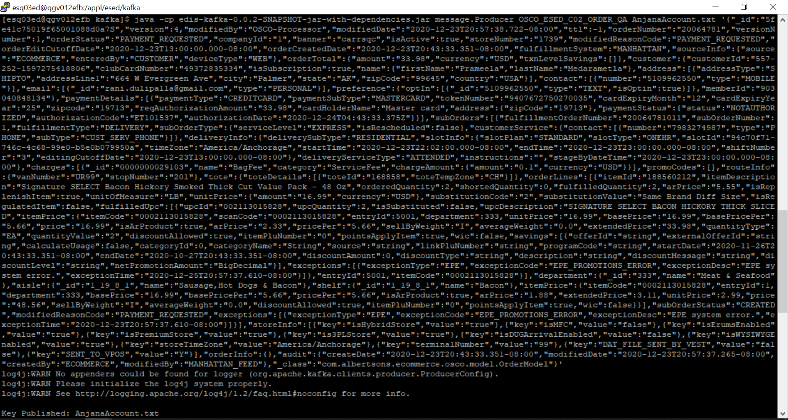

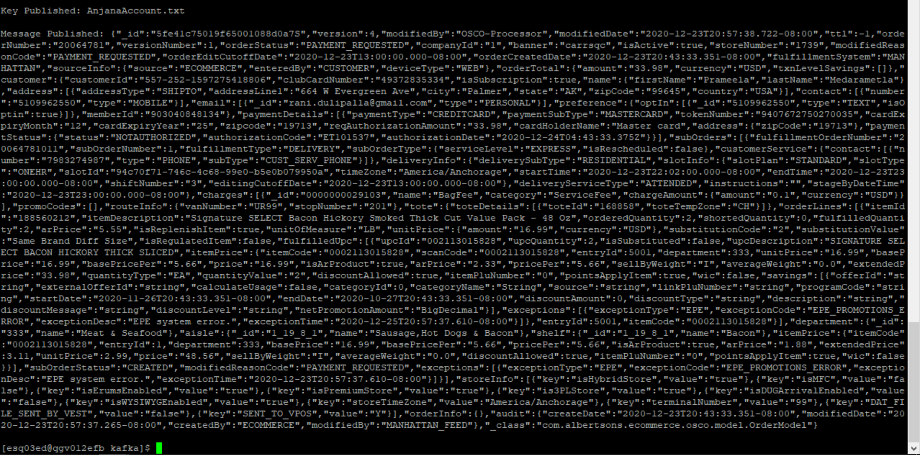

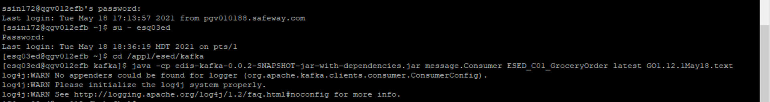

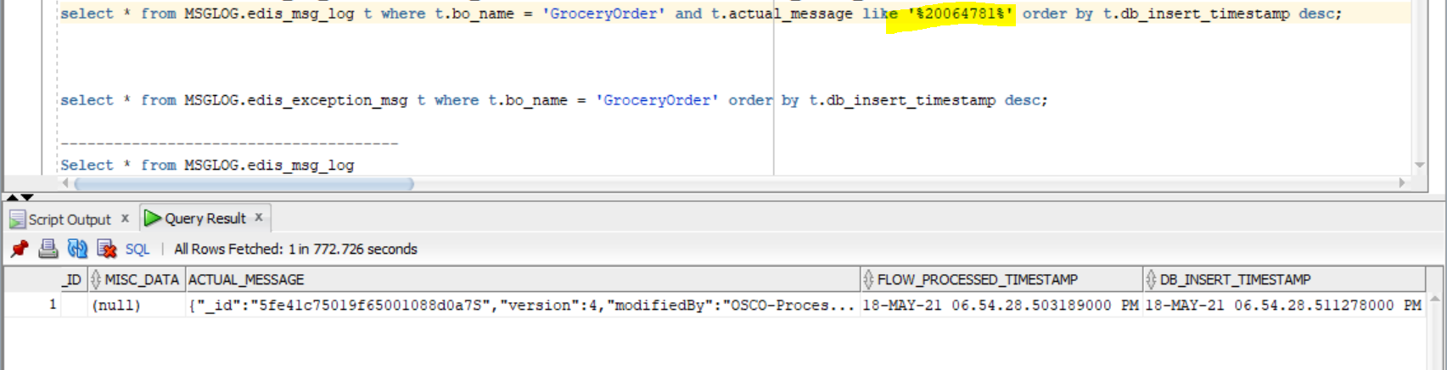

CMM xml-

<GetGroceryOrder

xmlns:Abs="https://collab.safeway.com/it/architecture/info/default.aspx">

<DocumentData>

<Abs:Document VersionId="v1.12.1" SystemEnvironmentCd="QA">

<Abs:DocumentID>GROCERY_ORDER</Abs:DocumentID>

<Abs:AlternateDocumentID>OSCO_ESED_C02_ORDER_QA_0_2103438_20210518185428505178</Abs:AlternateDocumentID>

<Abs:DocumentNm>GroceryOrder</Abs:DocumentNm>

<Abs:CreationDt>2021-05-18T18:54:28.505178</Abs:CreationDt>

<Abs:Description>GroceryOrderDetail</Abs:Description>

<Abs:SourceApplicationCd>OMS</Abs:SourceApplicationCd>

<Abs:TargetApplicationCd>EDIS</Abs:TargetApplicationCd>

<Abs:InternalFileTransferInd>Y</Abs:InternalFileTransferInd>

<Abs:DataClassification>

<Abs:DataClassificationLevel>

<Abs:Code>Internal</Abs:Code>

</Abs:DataClassificationLevel>

<Abs:BusinessSensitivityLevel>

<Abs:Code>Low</Abs:Code>

</Abs:BusinessSensitivityLevel>

<Abs:PHIdataInd>N</Abs:PHIdataInd>

<Abs:PCIdataInd>Y</Abs:PCIdataInd>

<Abs:PIIdataInd>Y</Abs:PIIdataInd>

</Abs:DataClassification>

</Abs:Document>

<Abs:DocumentAction>

<Abs:ActionTypeCd>UPDATE</Abs:ActionTypeCd>

<Abs:RecordTypeCd>CHANGE</Abs:RecordTypeCd>

</Abs:DocumentAction>

</DocumentData>

<GroceryOrderData>

<Abs:GroceryOrderHeader>

<Abs:OrderId>20064781</Abs:OrderId>

<Abs:OrderCreateTS>2020-12-23T20:43:33.351-08:00</Abs:OrderCreateTS>

<Abs:OrderModifyTS>2020-12-23T20:57:38.722-08:00</Abs:OrderModifyTS>

<Abs:CompanyId>1</Abs:CompanyId>

<Abs:VersionNbr>1</Abs:VersionNbr>

<Abs:OrderStatus>

<Abs:StatusTypeCd>PAYMENT_REQUESTED</Abs:StatusTypeCd>

</Abs:OrderStatus>

<Abs:OrderStatusReasonType/>

<Abs:OrderActionStatus/>

<Abs:EditCutoffDtTm>2020-12-23T13:00:00.000-08:00</Abs:EditCutoffDtTm>

<Abs:EditReasonType>

<Abs:Code>PAYMENT_REQUESTED</Abs:Code>

</Abs:EditReasonType>

<Abs:FulfillingFacility>

<Abs:RetailStoreId>1739</Abs:RetailStoreId>

<Abs:BannerCd>carrsqc</Abs:BannerCd>

<Abs:HybridStoreInd>Y</Abs:HybridStoreInd>

<Abs:MFCInd>N</Abs:MFCInd>

<Abs:ERUMSEnabledInd>Y</Abs:ERUMSEnabledInd>

<Abs:PremiumStoreInd>Y</Abs:PremiumStoreInd>

<Abs:ThirdPartyDeliveryOnlyInd>Y</Abs:ThirdPartyDeliveryOnlyInd>

</Abs:FulfillingFacility>

<Abs:GroceryOrderProfileType>

<Abs:ProfileType>

<Abs:Code>WYSIWYG</Abs:Code>

</Abs:ProfileType>

<Abs:ProfileValueInd>Y</Abs:ProfileValueInd>

</Abs:GroceryOrderProfileType>

<Abs:GroceryOrderProfileType>

<Abs:ProfileType>

<Abs:Code>taxExempt</Abs:Code>

</Abs:ProfileType>

</Abs:GroceryOrderProfileType>

<Abs:GroceryOrderProfileType>

<Abs:ProfileType>

<Abs:Code>AutoReplenishment</Abs:Code>

</Abs:ProfileType>

<Abs:ProfileValueInd>N</Abs:ProfileValueInd>

</Abs:GroceryOrderProfileType>

<Abs:RetailCustomer>

<Abs:CustomerId>557-252-1597275418806</Abs:CustomerId>

<Abs:CustomerAlternateId Abs:sequenceNbr="903040848134"/>

<Abs:CustomerNm>

<Abs:GivenNm>4MY7T5Tl</Abs:GivenNm>

<Abs:FamilyNm>Fd9yeY1GJZu</Abs:FamilyNm>

</Abs:CustomerNm>

<Abs:Contact>

<Abs:PhoneFaxContact TypeCode="MOBILE">

<Abs:PhoneNbrTxt>DjrwIOebYt</Abs:PhoneNbrTxt>

</Abs:PhoneFaxContact>

</Abs:Contact>

<Abs:Contact>

<Abs:DigitalContact>

<Abs:EmailStatuses Abs:typeCode="PERSONAL"/>

</Abs:DigitalContact>

</Abs:Contact>

<Abs:Contact>

<Abs:Address>

<Abs:AddressUsageTypeCd>epgjqg</Abs:AddressUsageTypeCd>

<Abs:AddressLine1txt>2uD C Z9abjDPdu dTT</Abs:AddressLine1txt>

<Abs:CityNm>KBvewj</Abs:CityNm>

<Abs:PostalZoneCd>DPyXG</Abs:PostalZoneCd>

<Abs:StateCd>sWh</Abs:StateCd>

<Abs:CountryCd>USA</Abs:CountryCd>

</Abs:Address>

</Abs:Contact>

<Abs:ClubCardNbr>49372835334</Abs:ClubCardNbr>

<Abs:CustomerPreference>

<Abs:PreferenceType>

<Abs:Code>TEXT</Abs:Code>

</Abs:PreferenceType>

<Abs:OptInInd>true</Abs:OptInInd>

</Abs:CustomerPreference>

<Abs:CustomerSubscription>

<Abs:SubscriptionTypeCd>Subscription</Abs:SubscriptionTypeCd>

<Abs:OptInInd>true</Abs:OptInInd>

</Abs:CustomerSubscription>

</Abs:RetailCustomer>

<Abs:CurrencyCd>USD</Abs:CurrencyCd>

<Abs:TotalAmt>33.98</Abs:TotalAmt>

<Abs:CustomerPayment>

<Abs:Tender>

<Abs:TenderId>9407672750270035</Abs:TenderId>

<Abs:TenderTypeCd>CREDITCARD</Abs:TenderTypeCd>

<Abs:TenderSubTypeCd>MASTERCARD</Abs:TenderSubTypeCd>

<Abs:HolderNm>ykZuKt onyv</Abs:HolderNm>

<Abs:ExpireMonthYearTxt>B93V</Abs:ExpireMonthYearTxt>

<Abs:BillingAddress>

<Abs:PostalZoneCd>kRLvh</Abs:PostalZoneCd>

</Abs:BillingAddress>

<Abs:PostalCd>shDZW</Abs:PostalCd>

<Abs:Token>

<Abs:TokenId>9407672750270035</Abs:TokenId>

<Abs:TokenTypeCd>CREDITCARD</Abs:TokenTypeCd>

</Abs:Token>

<Abs:Status>

<Abs:StatusCd>NOTAUTHORIZED</Abs:StatusCd>

</Abs:Status>

<Abs:RequiredAuthAmt>33.98</Abs:RequiredAuthAmt>

<Abs:AuthCd>ET101537</Abs:AuthCd>

<Abs:AuthDt>2020-12-24T04:43:33.375Z</Abs:AuthDt>

</Abs:Tender>

</Abs:CustomerPayment>

<Abs:CustomerSavings/>

<Abs:OrderRecordDateInfo>

<Abs:CreateDtTm>2020-12-23T20:43:33.351-08:00</Abs:CreateDtTm>

<Abs:CreateUserId>CUSTOMER</Abs:CreateUserId>

<Abs:UpdateDtTm>2020-12-23T20:57:38.722-08:00</Abs:UpdateDtTm>

<Abs:UpdateUserId>MANHATTAN_FEED</Abs:UpdateUserId>

</Abs:OrderRecordDateInfo>

<Abs:Device>

<Abs:Code>WEB</Abs:Code>

</Abs:Device>

<Abs:OrderCreatedDeviceType>

<Abs:Code>WEB</Abs:Code>

</Abs:OrderCreatedDeviceType>

<Abs:AffiliatePartnerType/>

<Abs:OrderSourceSystemType>

<Abs:Code>ECOMMERCE</Abs:Code>

</Abs:OrderSourceSystemType>

<Abs:FulFillmentSystemType>

<Abs:Code>MANHATTAN</Abs:Code>

</Abs:FulFillmentSystemType>

</Abs:GroceryOrderHeader>

<Abs:GrocerySubOrder>

<Abs:SubOrderNbr>1</Abs:SubOrderNbr>

<Abs:SubOrderStatus>

<Abs:StatusTypeCd>CREATED</Abs:StatusTypeCd>

</Abs:SubOrderStatus>

<Abs:StatusReasonType/>

<Abs:SubOrderActionStatus/>

<Abs:SubOrderServiceLevelType>

<Abs:Code>EXPRESS</Abs:Code>

</Abs:SubOrderServiceLevelType>

<Abs:GroceryOrderDetail>

<Abs:CartLineNbr>1</Abs:CartLineNbr>

<Abs:ItemId>

<Abs:SystemSpecificItemId>188560212</Abs:SystemSpecificItemId>

<Abs:InternalItemId>0002113015828</Abs:InternalItemId>

<Abs:BaseProductNbr>188560212</Abs:BaseProductNbr>

<Abs:PLUCd>0</Abs:PLUCd>

<Abs:ItemDescription>Signature SELECT Bacon Hickory Smoked Thick Cut Value Pack - 48 Oz</Abs:ItemDescription>

</Abs:ItemId>

<Abs:BasePriceAmt>16.9900</Abs:BasePriceAmt>

<Abs:UnitPriceAmt>16.9900</Abs:UnitPriceAmt>

<Abs:ExtendedUnitPriceAmt>2.9900</Abs:ExtendedUnitPriceAmt>

<Abs:ItemPriceAmt>48.5600</Abs:ItemPriceAmt>

<Abs:ExtendedItemPriceAmt>3.1100</Abs:ExtendedItemPriceAmt>

<Abs:PricePerAmt>5.6600</Abs:PricePerAmt>

<Abs:Quantity>2.0000</Abs:Quantity>

<Abs:UOM>

<Abs:UOMCd>LB</Abs:UOMCd>

</Abs:UOM>

<Abs:SellByWeightType>

<Abs:Code>I</Abs:Code>

</Abs:SellByWeightType>

<Abs:DiscountAllowedInd>true</Abs:DiscountAllowedInd>

<Abs:RewardAllowedInd>true</Abs:RewardAllowedInd>

<Abs:SubstitutionType>

<Abs:Code>2</Abs:Code>

<Abs:Description>Same Brand Diff Size</Abs:Description>

</Abs:SubstitutionType>

<Abs:CurrencyCd>USD</Abs:CurrencyCd>

<Abs:RegulatedItemInd>false</Abs:RegulatedItemInd>

<Abs:CouponPLUNbr>0</Abs:CouponPLUNbr>

<Abs:Department>

<Abs:Code>333</Abs:Code>

</Abs:Department>

<Abs:WICItemInd>false</Abs:WICItemInd>

<Abs:AutoReplenishmentOrderType>

<Abs:AROItemInd>true</Abs:AROItemInd>

<Abs:AROLineInd>true</Abs:AROLineInd>

<Abs:ItemPriceAmt>1.8800</Abs:ItemPriceAmt>

</Abs:AutoReplenishmentOrderType>

<Abs:DeliveredItem>

<Abs:DeliveredItemLineNbr>5001</Abs:DeliveredItemLineNbr>

<Abs:FulfillmentOrderId>20064781011</Abs:FulfillmentOrderId>

<Abs:Item>

<Abs:UPC>

<Abs:UPCNbr>002113015828</Abs:UPCNbr>

</Abs:UPC>

<Abs:SystemSpecificItemId>188560212</Abs:SystemSpecificItemId>

<Abs:InternalItemId>0002113015828</Abs:InternalItemId>

<Abs:PLUCd>0</Abs:PLUCd>

<Abs:BaseProductNbr>188560212</Abs:BaseProductNbr>

</Abs:Item>

<Abs:SubstitutedItemInd>false</Abs:SubstitutedItemInd>

<Abs:Quantity>2</Abs:Quantity>

<Abs:UOM>

<Abs:UOMCd>EA</Abs:UOMCd>

</Abs:UOM>

<Abs:SellByWeightType>

<Abs:Code>I</Abs:Code>

</Abs:SellByWeightType>

<Abs:BasePriceAmt>16.9900</Abs:BasePriceAmt>

<Abs:UnitPriceAmt>16.9900</Abs:UnitPriceAmt>

<Abs:ExtendedUnitPriceAmt>16.9900</Abs:ExtendedUnitPriceAmt>

<Abs:ItemPriceAmt>16.9900</Abs:ItemPriceAmt>

<Abs:ExtendedItemPriceAmt>33.9800</Abs:ExtendedItemPriceAmt>

<Abs:PricePerAmt>5.6600</Abs:PricePerAmt>

<Abs:RegulatedItemInd>false</Abs:RegulatedItemInd>

<Abs:CouponPLUNbr>0</Abs:CouponPLUNbr>

<Abs:CustomerOffers>

<Abs:OfferId>string</Abs:OfferId>

<Abs:ReferenceOfferId>string</Abs:ReferenceOfferId>

<Abs:OfferSourceType>

<Abs:Code>string</Abs:Code>

</Abs:OfferSourceType>

</Abs:CustomerOffers>

<Abs:RewardAllowedInd>true</Abs:RewardAllowedInd>

<Abs:DiscountAllowedInd>true</Abs:DiscountAllowedInd>

<Abs:WICItemInd>false</Abs:WICItemInd>

<Abs:CustomerSavings>

<Abs:SavingsCategoryType>

<Abs:OfferId>string</Abs:OfferId>

<Abs:SavingsCategoryId>0</Abs:SavingsCategoryId>

<Abs:SavingsCategoryNm>String</Abs:SavingsCategoryNm>

<Abs:SavingsAmt>0.00</Abs:SavingsAmt>

</Abs:SavingsCategoryType>

</Abs:CustomerSavings>

<Abs:DeliveredItemExceptionType>

<Abs:ExceptionType>

<Abs:Code>EPE</Abs:Code>

</Abs:ExceptionType>

<Abs:ExceptionCd>EPE_PROMOTIONS_ERROR</Abs:ExceptionCd>

<Abs:ExceptionDsc>EPE system error.</Abs:ExceptionDsc>

<Abs:ExceptionCreateTs>2020-12-25T20:57:37.610-08:00</Abs:ExceptionCreateTs>

</Abs:DeliveredItemExceptionType>

<Abs:AutoReplenishmentOrderType>

<Abs:AROItemInd>true</Abs:AROItemInd>

<Abs:AROLineInd>true</Abs:AROLineInd>

<Abs:ItemPriceAmt>2.3300</Abs:ItemPriceAmt>

</Abs:AutoReplenishmentOrderType>

</Abs:DeliveredItem>

<Abs:OrderQty>2.0000</Abs:OrderQty>

<Abs:FulfilledQty>2.0000</Abs:FulfilledQty>

<Abs:CustomerSavings/>

</Abs:GroceryOrderDetail>

<Abs:FullFillmentType>

<Abs:Code>DELIVERY</Abs:Code>

</Abs:FullFillmentType>

<Abs:PickupInfo>

<Abs:PickupSlot/>

<Abs:PickupSlotType/>

</Abs:PickupInfo>

<Abs:DeliveryInfo>

<Abs:CustomerType>

<Abs:Code>RESIDENTIAL</Abs:Code>

</Abs:CustomerType>

<Abs:DeliverySlotId>94c70f71-746c-4c68-99e0-b5e0b079950a</Abs:DeliverySlotId>

<Abs:DeliverySlotType>

<Abs:Code>ONEHR</Abs:Code>

</Abs:DeliverySlotType>

<Abs:DeliveryServiceType>

<Abs:Code>ATTENDED</Abs:Code>

</Abs:DeliveryServiceType>

<Abs:SlotPlan>

<Abs:Code>STANDARD</Abs:Code>

</Abs:SlotPlan>

<Abs:StartDttm>2020-12-23T22:02:00.000-08:00</Abs:StartDttm>

<Abs:EndDttm>2020-12-23T23:00:00.000-08:00</Abs:EndDttm>

<Abs:SlotExpiryDttm>2020-12-23T23:00:00.000-08:00</Abs:SlotExpiryDttm>

<Abs:StageByDttm>2020-12-23T23:00:00.000-08:00</Abs:StageByDttm>

<Abs:EditCutoffDtTm>2020-12-23T13:00:00.000-08:00</Abs:EditCutoffDtTm>

<Abs:CustomerInstructionTxt></Abs:CustomerInstructionTxt>

<Abs:DeliveryTimeZoneCd>America/Anchorage</Abs:DeliveryTimeZoneCd>

</Abs:DeliveryInfo>

<Abs:ChargeInfo>

<Abs:Charge>

<Abs:Description>BagFee</Abs:Description>

</Abs:Charge>

<Abs:ChargeCategory>

<Abs:Code>ServiceFee</Abs:Code>

</Abs:ChargeCategory>

<Abs:ChargeAmt>0.10</Abs:ChargeAmt>

<Abs:CurrencyCd>USD</Abs:CurrencyCd>

</Abs:ChargeInfo>

<Abs:CustomerService>

<Abs:PhoneFaxContact TypeCode="PHONE">

<Abs:PhoneNbrTxt>7983274987</Abs:PhoneNbrTxt>

<Abs:PhonePurposes>

<Abs:PurposeDsc>CUST_SERV_PHONE</Abs:PurposeDsc>

</Abs:PhonePurposes>

</Abs:PhoneFaxContact>

</Abs:CustomerService>

<Abs:InstructionTxt></Abs:InstructionTxt>

<Abs:GrocerySubOrderExceptionType>

<Abs:ExceptionType>

<Abs:Code>EPE</Abs:Code>

</Abs:ExceptionType>

<Abs:ExceptionCd>EPE_PROMOTIONS_ERROR</Abs:ExceptionCd>

<Abs:ExceptionDsc>EPE system error.</Abs:ExceptionDsc>

<Abs:ExceptionCreateTs>2020-12-23T20:57:37.610-08:00</Abs:ExceptionCreateTs>

</Abs:GrocerySubOrderExceptionType>

</Abs:GrocerySubOrder>

</GroceryOrderData>

</GetGroceryOrder>

Scenario:2 ERUM Source-

Sample JSON-

{"orderNumber":"20054741A","versionNumber":1,"orderStatus":"CREATED","companyId":"1","banner":"carrsqc","storeNumber":"1739","messageAction":"CREATE","orderEditCutoffDate":"2020-11-10T08:59:59.000Z","orderCreatedDate":"2020-11-09T19:16:23.691Z","sourceInfo":{"source":"ECOMMERCE","enteredBy":"CUSTOMER","deviceType":"WEB"},"orderTotal":{"amount":61.42,"currency":"USD","totalCardSavings":38.48,"cardSavings":[{"savingsCategoryName":"Employee Savings","savingsAmount":3.34},{"savingsCategoryName":"Just for U Savings","savingsAmount":34.95},{"savingsCategoryName":"Club Card Savings","savingsAmount":0.19}],"txnLevelSavings":[{"offerId":"618960","externalOfferId":"618960","categoryId":72,"categoryName":"006-Employee Savings","source":"CPE","linkpluNumber":"0","programCode":"SC","startDate":"2020-09-09T00:00:00.000Z","endDate":"2021-10-09T00:00:00.000Z","discountAmount":3.34,"discountType":"Percent Off","description":"Buy 5% off National Brand and 10% off on Own Brandsin September Standard Exclusion Apply. At 5% and 10% Off.","discountMessage":"","discountLevel":"Basket Level","netPromotionAmount":63.42,"points":[]}]},"customer":{"customerId":"557-106-1603910060390","clubCardNumber":"49155237621","isSubscription":false,"name":{"firstName":"test","lastName":"testing"},"address":[{"addressType":"SHIP-TO","addressLine1":"664 W Evergreen Ave","city":"Palmer","state":"AK","zipCode":"99645","country":"USA"}],"contact":[{"number":"5468465465","type":"MOBILE"}],"email":[{"id":"testqa2.offer9@yopmail.com","type":"PERSONAL"}],"preference":{"optIn":[{"type":"TEXT","id":"5468465465","isOptin":true}]},"memberId":"845029197637"},"paymentDetails":[{"paymentType":"CREDITCARD","paymentSubType":"VISA","tokenNumber":"9495846215171111","cardExpiryMonth":"12","cardExpiryYear":"24","zipcode":"94588","reqAuthorizationAmount":"61.42","cardHolderName":"mayur","address":{"zipCode":"94588"},"paymentStatus":{"status":"NOTAUTHORIZED","authorizationCode":"ET111747","authorizationDate":"2020-11-09T19:16:23.728Z"}}],"subOrders":[{"subOrderNumber":1,"fulfillmentType":"DUG","customerService":{"contact":[{"number":"8732748978","type":"PHONE","subType":"DUG_VIRTUAL_PHONE"},{"number":"7983274987","type":"PHONE","subType":"CUST_SERV_PHONE"}]},"deliveryInfo":{"slotInfo":{"slotPlan":"STANDARD","slotType":"ONEHR","slotId":"8037dc04-5d56-4b1d-9168-3d500092fb46","timeZone":"America/Anchorage","startTime":"2020-11-11T17:00:00.000Z","endTime":"2020-11-11T18:00:00.000Z","editingCutoffDate":"2020-11-11T15:00:00.000Z","lastPickupTime":"2020-11-12T05:00:00.000Z"},"instructions":"","pickupInfo":{"locationType":"STORE","locationId":"1739"},"stageByDateTime":"2020-11-11T18:00:00.000Z"},"charges":[{"id":"0000000029103","name":"BagFee","category":"ServiceFee","chargeAmount":{"amount":0.1,"currency":"USD"}}],"promoCodes":[{"code":"NATUREVALLEY","description":"Save $2 when you buy any 2 participating Nature Valley items. Limit 1 per transaction.","pluCode":"0000000010907"}],"orderLines":[{"itemId":"111200054","itemDescription":"Nature Valley Granola Bars Crunchy Oats n Honey - 6-1.49 Oz","orderedQuantity":2,"unitOfMeasure":"OZ","unitPrice":{"amount":4.49,"currency":"USD"},"substitutionCode":"2","substitutionValue":"Same Brand Diff Size","isRegulatedItem":false,"department":{"id":"301","name":"Breakfast & Cereal"},"aisle":{"id":"1_7_1_3","name":"Breakfast Bars & Bites"},"shelf":{"id":"1_7_1_3","name":"Granola Bars"},"itemPrice":{"itemCode":"0001600026460","entryId":6,"department":301,"unitPrice":4.49,"basePrice":4.49,"pricePer":0.5,"price":2.17,"sellByWeight":"I","averageWeight":0,"clubCardSaving":0,"extendedPrice":8.98,"quantityType":"EA","quantityValue":2,"discountAllowed":true,"itemPluNumber":"0","pointsApplyItem":true,"wic":false,"netPromotionAmount":8.52,"savings":[{"offerId":"618960","externalOfferId":"618960","categoryId":72,"source":"CPE","netPromotionAmount":8.52,"programCode":"SC","startDate":"2020-09-09T00:00:00.000Z","endDate":"2021-10-09T00:00:00.000Z","discountAmount":0.46,"discountType":"Percent Off","description":"Buy 5% off National Brand and 10% off on Own Brandsin September Standard Exclusion Apply. At 5% and 10% Off.","discountMessage":"","discountLevel":"Basket Level","calculateUsage":false}]}},{"itemId":"960023871","itemDescription":"Nature Valley Granola Bars Crunchy Oats n Honey Value Pack - 12-1.49 Oz","orderedQuantity":1,"unitOfMeasure":"OZ","unitPrice":{"amount":6.99,"currency":"USD"},"substitutionCode":"2","substitutionValue":"Same Brand Diff Size","isRegulatedItem":false,"department":{"id":"301","name":"Breakfast & Cereal"},"aisle":{"id":"1_7_1_3","name":"Breakfast Bars & Bites"},"shelf":{"id":"1_7_1_3","name":"Granola Bars"},"itemPrice":{"itemCode":"0001600043101","entryId":2,"department":301,"unitPrice":6.99,"basePrice":6.99,"pricePer":0.39,"sellByWeight":"I","averageWeight":0,"clubCardSaving":0,"extendedPrice":6.99,"quantityType":"EA","quantityValue":1,"discountAllowed":true,"itemPluNumber":"0","pointsApplyItem":true,"wic":false,"netPromotionAmount":6.64,"savings":[{"offerId":"618960","externalOfferId":"618960","categoryId":72,"source":"CPE","netPromotionAmount":6.64,"programCode":"SC","startDate":"2020-09-09T00:00:00.000Z","endDate":"2021-10-09T00:00:00.000Z","discountAmount":0.35,"discountType":"Percent Off","description":"Buy 5% off National Brand and 10% off on Own Brandsin September Standard Exclusion Apply. At 5% and 10% Off.","discountMessage":"","discountLevel":"Basket Level","calculateUsage":false}]}},{"itemId":"111200546","itemDescription":"Nature Valley Granola Bars Sweet & Salty Nut Peanut - 6-1.2 Oz","orderedQuantity":1,"unitOfMeasure":"OZ","unitPrice":{"amount":4.49,"currency":"USD"},"substitutionCode":"2","substitutionValue":"Same Brand Diff Size","isRegulatedItem":false,"department":{"id":"301","name":"Breakfast & Cereal"},"aisle":{"id":"1_7_1_3","name":"Breakfast Bars & Bites"},"shelf":{"id":"1_7_1_3","name":"Granola Bars"},"itemPrice":{"itemCode":"0001600027707","entryId":1,"department":301,"unitPrice":4.49,"basePrice":4.49,"pricePer":0.61,"sellByWeight":"I","averageWeight":0,"clubCardSaving":0,"extendedPrice":4.49,"quantityType":"EA","quantityValue":1,"discountAllowed":true,"itemPluNumber":"0","pointsApplyItem":true,"wic":false,"netPromotionAmount":4.26,"savings":[{"offerId":"618960","externalOfferId":"618960","categoryId":72,"source":"CPE","netPromotionAmount":4.26,"programCode":"SC","startDate":"2020-09-09T00:00:00.000Z","endDate":"2021-10-09T00:00:00.000Z","discountAmount":0.23,"discountType":"Percent Off","description":"Buy 5% off National Brand and 10% off on Own Brandsin September Standard Exclusion Apply. At 5% and 10% Off.","discountMessage":"","discountLevel":"Basket Level","calculateUsage":false}]}},{"itemId":"960171419","itemDescription":"Junior Mints Creamy Mints In Pure Chocolate Box - 4 Oz","orderedQuantity":5,"unitOfMeasure":"OZ","unitPrice":{"amount":1.99,"currency":"USD"},"substitutionCode":"2","substitutionValue":"Same Brand Diff Size","isRegulatedItem":false,"department":{"id":"318","name":"Cookies, Snacks & Candy"},"aisle":{"id":"1_24_16_1","name":"Chocolate"},"shelf":{"id":"1_24_16_1","name":"Chocolate"},"itemPrice":{"itemCode":"0007172053944","entryId":4,"department":318,"unitPrice":1.99,"basePrice":1.99,"pricePer":0.57,"sellByWeight":"I","averageWeight":0,"clubCardSaving":0,"extendedPrice":9.95,"quantityType":"EA","quantityValue":5,"discountAllowed":true,"itemPluNumber":"0","pointsApplyItem":true,"wic":false,"netPromotionAmount":4.77,"savings":[{"offerId":"617481","externalOfferId":"2720W4220_385919","categoryId":70,"source":"CPE","netPromotionAmount":5,"programCode":"SC","startDate":"2020-09-24T00:00:00.000Z","endDate":"2020-12-24T00:00:00.000Z","discountAmount":4.95,"discountType":"Price Point (Items)","description":"BuyRockstarEnergy Drink15.5 to 16-oz. +Deposit where applicable test","discountMessage":"J4U RockstarEnergy","discountLevel":"Item Level","calculateUsage":false},{"offerId":"618960","externalOfferId":"618960","categoryId":72,"source":"CPE","netPromotionAmount":4.77,"programCode":"SC","startDate":"2020-09-09T00:00:00.000Z","endDate":"2021-10-09T00:00:00.000Z","discountAmount":0.23,"discountType":"Percent Off","description":"Buy 5% off National Brand and 10% off on Own Brandsin September Standard Exclusion Apply. At 5% and 10% Off.","discountMessage":"","discountLevel":"Basket Level","calculateUsage":false}]}},{"itemId":"960087008","itemDescription":"Horizon Organic Milk Lowfat 1% Milkfat - 8 Fl. Oz.","orderedQuantity":1,"unitOfMeasure":"FZ","unitPrice":{"amount":1.5,"currency":"USD"},"substitutionCode":"2","substitutionValue":"Same Brand Diff Size","isRegulatedItem":false,"department":{"id":"301","name":"Dairy, Eggs & Cheese"},"aisle":{"id":"1_11_4_5","name":"Milk & Cream"},"shelf":{"id":"1_11_4_5","name":"Milk"},"itemPrice":{"itemCode":"0074236520825","entryId":5,"department":301,"unitPrice":1.5,"basePrice":1.69,"pricePer":0.19,"sellByWeight":"I","averageWeight":0,"clubCardSaving":0.19,"extendedPrice":1.5,"quantityType":"EA","quantityValue":1,"discountAllowed":true,"linkPluNumber":"248000481027","itemPluNumber":"0","pointsApplyItem":true,"wic":false,"startDate":"2020-06-29T06:00:01.000Z","endDate":"2020-10-01T05:59:00.000Z","netPromotionAmount":1.43,"savings":[{"offerId":"618960","externalOfferId":"618960","categoryId":72,"source":"CPE","netPromotionAmount":1.43,"programCode":"SC","startDate":"2020-09-09T00:00:00.000Z","endDate":"2021-10-09T00:00:00.000Z","discountAmount":0.07,"discountType":"Percent Off","description":"Buy 5% off National Brand and 10% off on Own Brandsin September Standard Exclusion Apply. At 5% and 10% Off.","discountMessage":"","discountLevel":"Basket Level","calculateUsage":false}]}},{"itemId":"127106031","itemDescription":"Mission Tortillas Corn Yellow Super Soft Extra Thin 24 Count - 16 Oz","orderedQuantity":20,"unitOfMeasure":"OZ","unitPrice":{"amount":3.49,"currency":"USD"},"substitutionCode":"2","substitutionValue":"Same Brand Diff Size","isRegulatedItem":false,"department":{"id":"301","name":"International Cuisine"},"aisle":{"id":"1_13_2_8","name":"Hispanic Foods"},"shelf":{"id":"1_13_2_8","name":"Tortillas, Tacos & Wraps"},"itemPrice":{"itemCode":"0007373100328","entryId":3,"department":301,"unitPrice":3.49,"basePrice":3.49,"pricePer":0.22,"sellByWeight":"I","averageWeight":0,"clubCardSaving":0,"extendedPrice":69.8,"quantityType":"EA","quantityValue":20,"discountAllowed":true,"itemPluNumber":"0","pointsApplyItem":true,"wic":true,"netPromotionAmount":37.8,"savings":[{"offerId":"617480","externalOfferId":"2720W4220_385435","categoryId":70,"source":"CPE","netPromotionAmount":39.8,"programCode":"SC","startDate":"2020-09-24T00:00:00.000Z","endDate":"2020-12-24T00:00:00.000Z","discountAmount":30,"discountType":"Price Point (Items)","description":"BuyMissionSuper Size Yellow Corn Tortillas24-ct.","discountMessage":"J4U MissionSuper S","discountLevel":"Item Level","calculateUsage":false},{"offerId":"618960","externalOfferId":"618960","categoryId":72,"source":"CPE","netPromotionAmount":37.8,"programCode":"SC","startDate":"2020-09-09T00:00:00.000Z","endDate":"2021-10-09T00:00:00.000Z","discountAmount":2,"discountType":"Percent Off","description":"Buy 5% off National Brand and 10% off on Own Brandsin September Standard Exclusion Apply. At 5% and 10% Off.","discountMessage":"","discountLevel":"Basket Level","calculateUsage":false}]}}],"messageAction":"CREATE"}],"storeInfo":[{"key":"isHybridStore","value":"true"},{"key":"isMFC","value":"false"},{"key":"isErumsEnabled","value":"true"},{"key":"isPremiumStore","value":"true"},{"key":"is3PLStore","value":"true"},{"key":"isDUGArrivalEnabled","value":"false"},{"key":"isWYSIWYGEnabled","value":"true"},{"key":"storeTimeZone","value":"America/Anchorage"},{"key":"terminalNumber","value":"99"}]}

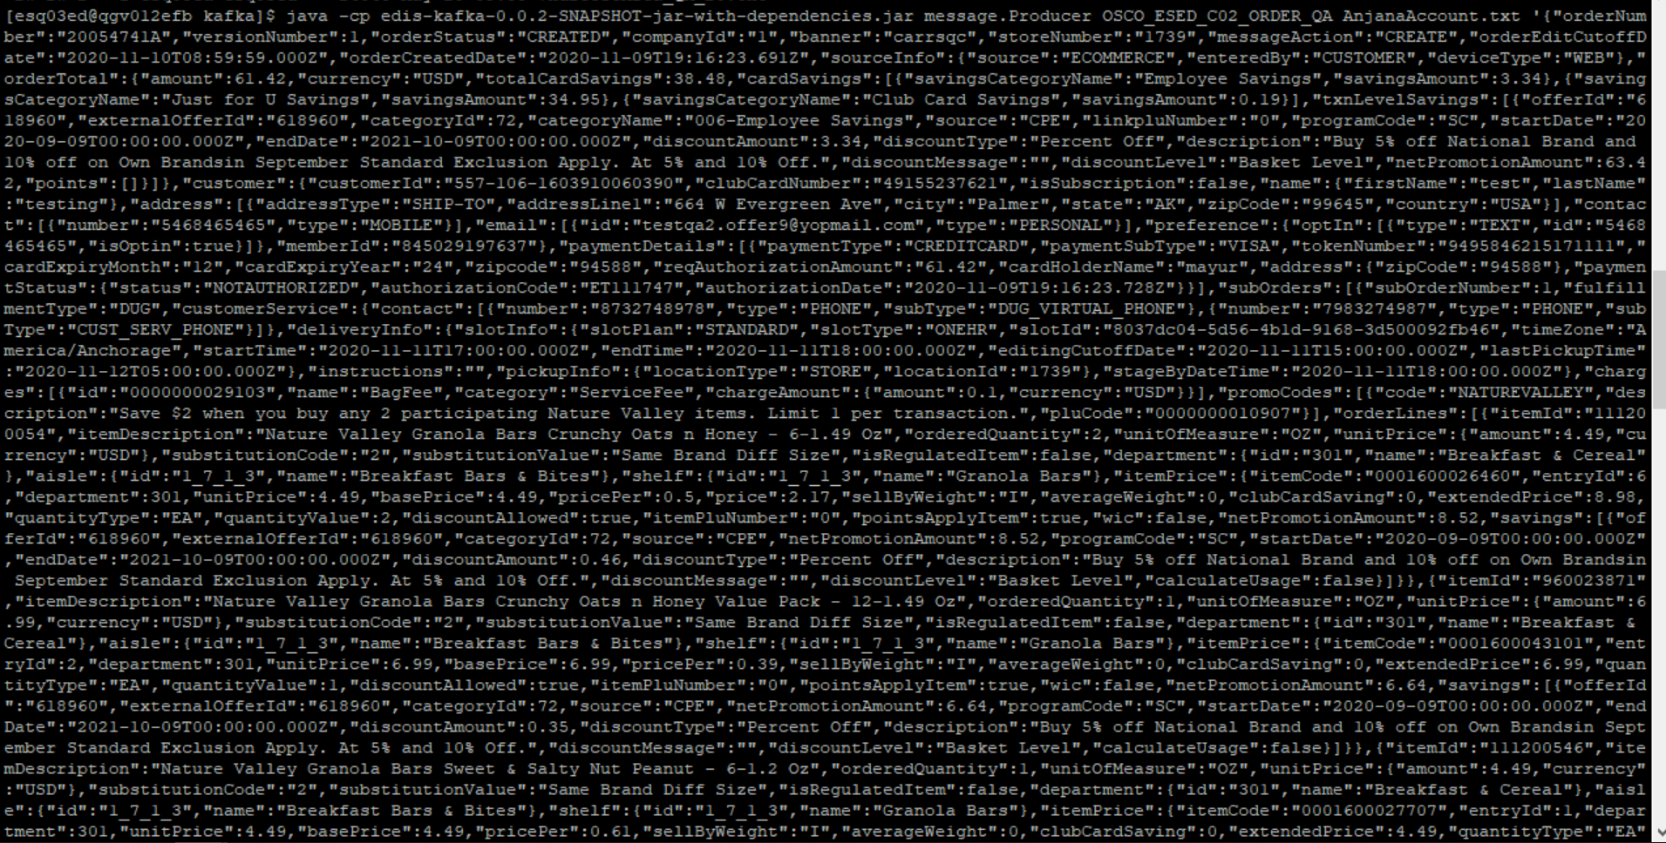

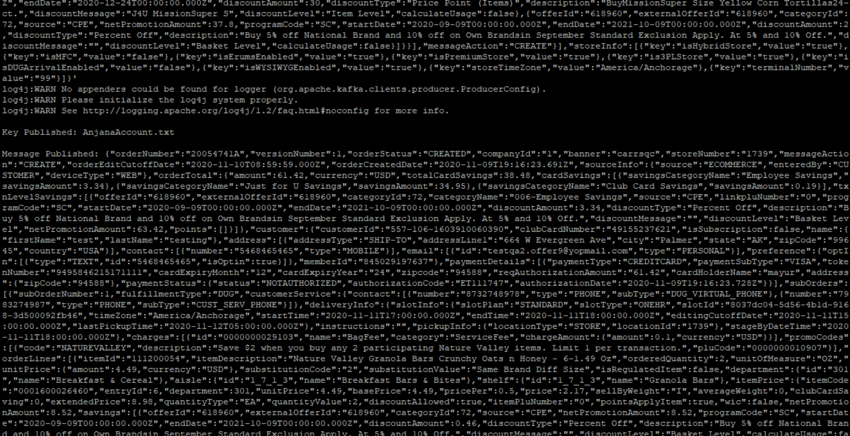

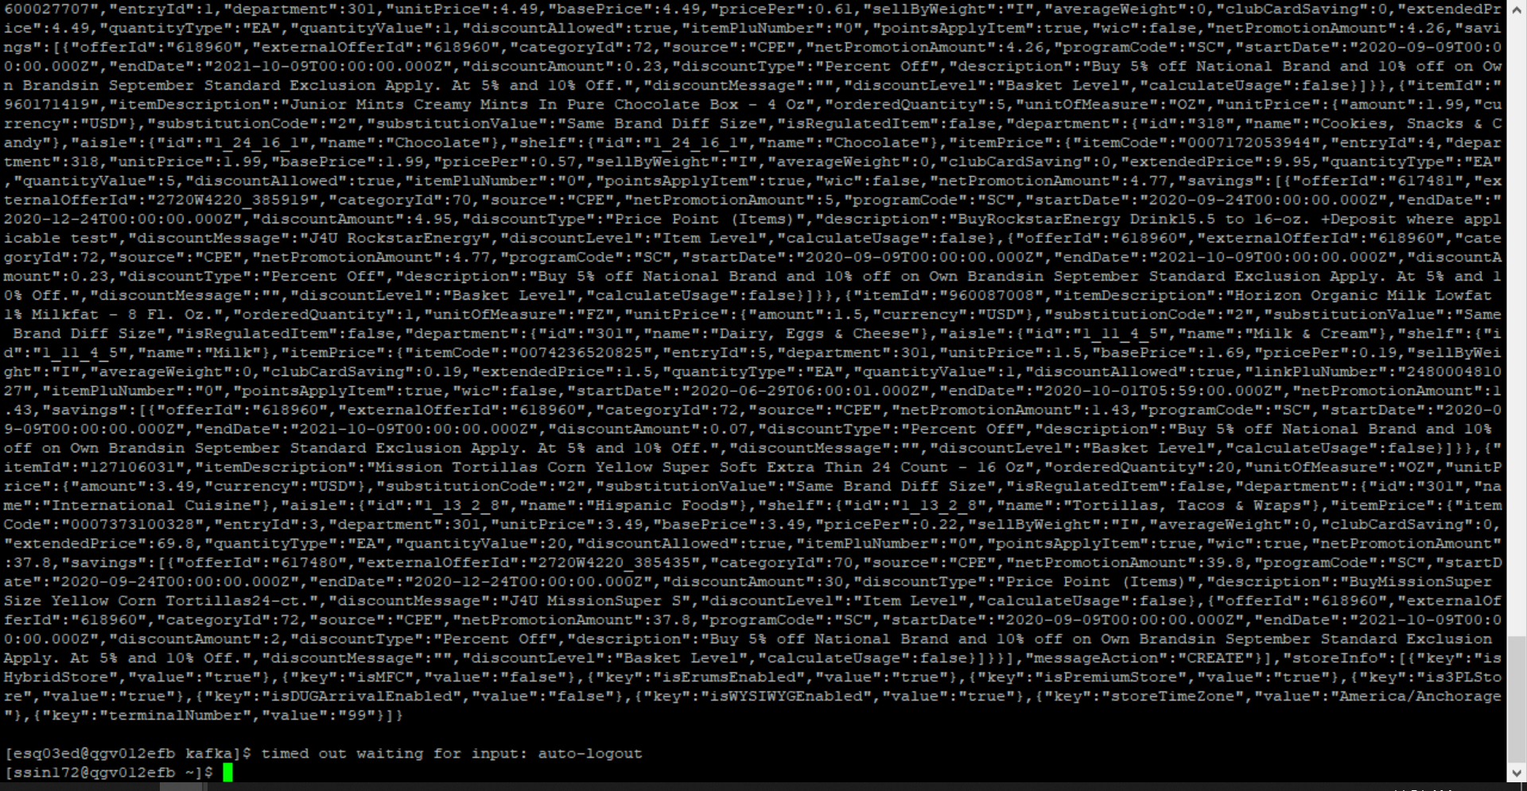



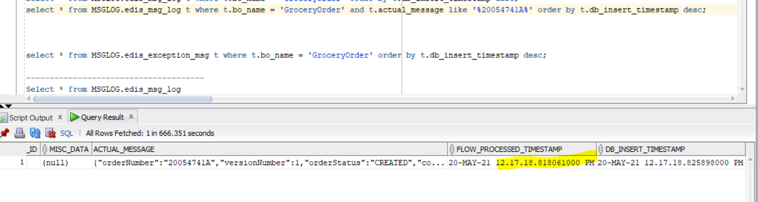

CMM XML-

<GetGroceryOrder

xmlns:Abs="https://collab.safeway.com/it/architecture/info/default.aspx">

<DocumentData>

<Abs:Document VersionId="v1.12.1" SystemEnvironmentCd="QA">

<Abs:DocumentID>GROCERY_ORDER</Abs:DocumentID>

<Abs:AlternateDocumentID>OSCO_ESED_C02_ORDER_QA_0_2112024_20210520121718819314</Abs:AlternateDocumentID>

<Abs:DocumentNm>GroceryOrder</Abs:DocumentNm>

<Abs:CreationDt>2021-05-20T12:17:18.819314</Abs:CreationDt>

<Abs:Description>GroceryOrderDetail</Abs:Description>

<Abs:SourceApplicationCd>OMS</Abs:SourceApplicationCd>

<Abs:TargetApplicationCd>EDIS</Abs:TargetApplicationCd>

<Abs:InternalFileTransferInd>Y</Abs:InternalFileTransferInd>

<Abs:DataClassification>

<Abs:DataClassificationLevel>

<Abs:Code>Internal</Abs:Code>

</Abs:DataClassificationLevel>

<Abs:BusinessSensitivityLevel>

<Abs:Code>Low</Abs:Code>

</Abs:BusinessSensitivityLevel>

<Abs:PHIdataInd>N</Abs:PHIdataInd>

<Abs:PCIdataInd>Y</Abs:PCIdataInd>

<Abs:PIIdataInd>Y</Abs:PIIdataInd>

</Abs:DataClassification>

</Abs:Document>

<Abs:DocumentAction>

<Abs:ActionTypeCd>UPDATE</Abs:ActionTypeCd>

<Abs:RecordTypeCd>CHANGE</Abs:RecordTypeCd>

</Abs:DocumentAction>

</DocumentData>

<GroceryOrderData>

<Abs:GroceryOrderHeader>

<Abs:OrderId>20054741A</Abs:OrderId>

<Abs:OrderCreateTS>2020-11-09T19:16:23.691Z</Abs:OrderCreateTS>

<Abs:CompanyId>1</Abs:CompanyId>

<Abs:VersionNbr>1</Abs:VersionNbr>

<Abs:OrderStatus>

<Abs:StatusTypeCd>CREATED</Abs:StatusTypeCd>

</Abs:OrderStatus>

<Abs:OrderStatusReasonType/>

<Abs:OrderActionStatus>

<Abs:StatusTypeCd>CREATE</Abs:StatusTypeCd>

</Abs:OrderActionStatus>

<Abs:EditCutoffDtTm>2020-11-10T08:59:59.000Z</Abs:EditCutoffDtTm>

<Abs:EditReasonType/>

<Abs:FulfillingFacility>

<Abs:RetailStoreId>1739</Abs:RetailStoreId>

<Abs:BannerCd>carrsqc</Abs:BannerCd>

<Abs:HybridStoreInd>Y</Abs:HybridStoreInd>

<Abs:MFCInd>N</Abs:MFCInd>

<Abs:ERUMSEnabledInd>Y</Abs:ERUMSEnabledInd>

<Abs:PremiumStoreInd>Y</Abs:PremiumStoreInd>

<Abs:ThirdPartyDeliveryOnlyInd>Y</Abs:ThirdPartyDeliveryOnlyInd>

</Abs:FulfillingFacility>

<Abs:GroceryOrderProfileType>

<Abs:ProfileType>

<Abs:Code>WYSIWYG</Abs:Code>

</Abs:ProfileType>

<Abs:ProfileValueInd>Y</Abs:ProfileValueInd>

</Abs:GroceryOrderProfileType>

<Abs:GroceryOrderProfileType>

<Abs:ProfileType>

<Abs:Code>taxExempt</Abs:Code>

</Abs:ProfileType>

</Abs:GroceryOrderProfileType>

<Abs:GroceryOrderProfileType>

<Abs:ProfileType>

<Abs:Code>AutoReplenishment</Abs:Code>

</Abs:ProfileType>

<Abs:ProfileValueInd>N</Abs:ProfileValueInd>

</Abs:GroceryOrderProfileType>

<Abs:RetailCustomer>

<Abs:CustomerId>557-106-1603910060390</Abs:CustomerId>

<Abs:CustomerAlternateId Abs:sequenceNbr="845029197637"/>

<Abs:CustomerNm>

<Abs:GivenNm>h42E</Abs:GivenNm>

<Abs:FamilyNm>zNJBfyd</Abs:FamilyNm>

</Abs:CustomerNm>

<Abs:Contact>

<Abs:PhoneFaxContact TypeCode="MOBILE">

<Abs:PhoneNbrTxt>PvTKMXBq44</Abs:PhoneNbrTxt>

</Abs:PhoneFaxContact>

</Abs:Contact>

<Abs:Contact>

<Abs:DigitalContact>

<Abs:DigitalAddress>qtdu9Mu.WycT9A@TJBRZ4m.Fwy</Abs:DigitalAddress>

<Abs:EmailStatuses Abs:typeCode="PERSONAL"/>

</Abs:DigitalContact>

</Abs:Contact>

<Abs:Contact>

<Abs:Address>

<Abs:AddressUsageTypeCd>epgj-qg</Abs:AddressUsageTypeCd>

<Abs:AddressLine1txt>2uD C Z9abjDPdu dTT</Abs:AddressLine1txt>

<Abs:CityNm>KBvewj</Abs:CityNm>

<Abs:PostalZoneCd>DPyXG</Abs:PostalZoneCd>

<Abs:StateCd>sWh</Abs:StateCd>

<Abs:CountryCd>USA</Abs:CountryCd>

</Abs:Address>

</Abs:Contact>

<Abs:ClubCardNbr>49155237621</Abs:ClubCardNbr>

<Abs:CustomerPreference>

<Abs:PreferenceType>

<Abs:Code>TEXT</Abs:Code>

</Abs:PreferenceType>

<Abs:OptInContactNbr>5468465465</Abs:OptInContactNbr>

<Abs:OptInInd>true</Abs:OptInInd>

</Abs:CustomerPreference>

<Abs:CustomerSubscription>

<Abs:OptInInd>false</Abs:OptInInd>

</Abs:CustomerSubscription>

</Abs:RetailCustomer>

<Abs:CurrencyCd>USD</Abs:CurrencyCd>

<Abs:TotalAmt>61.42</Abs:TotalAmt>

<Abs:CustomerOffers>

<Abs:OfferId>618960</Abs:OfferId>

<Abs:ReferenceOfferId>618960</Abs:ReferenceOfferId>

<Abs:OfferDiscountAmt>3.34</Abs:OfferDiscountAmt>

</Abs:CustomerOffers>

<Abs:CustomerPayment>

<Abs:Tender>

<Abs:TenderId>9495846215171111</Abs:TenderId>

<Abs:TenderTypeCd>CREDITCARD</Abs:TenderTypeCd>

<Abs:TenderSubTypeCd>VISA</Abs:TenderSubTypeCd>

<Abs:HolderNm>EcLq1</Abs:HolderNm>

<Abs:ExpireMonthYearTxt>EYIJ</Abs:ExpireMonthYearTxt>

<Abs:BillingAddress>

<Abs:PostalZoneCd>LCx3p</Abs:PostalZoneCd>

</Abs:BillingAddress>

<Abs:PostalCd>nXOca</Abs:PostalCd>

<Abs:Token>

<Abs:TokenId>9495846215171111</Abs:TokenId>

<Abs:TokenTypeCd>CREDITCARD</Abs:TokenTypeCd>

</Abs:Token>

<Abs:Status>

<Abs:StatusCd>NOTAUTHORIZED</Abs:StatusCd>

</Abs:Status>

<Abs:RequiredAuthAmt>61.42</Abs:RequiredAuthAmt>

<Abs:AuthCd>ET111747</Abs:AuthCd>

<Abs:AuthDt>2020-11-09T19:16:23.728Z</Abs:AuthDt>

</Abs:Tender>

</Abs:CustomerPayment>

<Abs:CustomerSavings>

<Abs:TotalCustomerSavingsAmt>38.48</Abs:TotalCustomerSavingsAmt>

<Abs:SavingsCategoryType>

<Abs:SavingsCategoryNm>Employee Savings</Abs:SavingsCategoryNm>

<Abs:SavingsAmt>3.34</Abs:SavingsAmt>

</Abs:SavingsCategoryType>

<Abs:SavingsCategoryType>

<Abs:SavingsCategoryNm>Just for U Savings</Abs:SavingsCategoryNm>

<Abs:SavingsAmt>34.95</Abs:SavingsAmt>

</Abs:SavingsCategoryType>

<Abs:SavingsCategoryType>

<Abs:SavingsCategoryNm>Club Card Savings</Abs:SavingsCategoryNm>

<Abs:SavingsAmt>0.19</Abs:SavingsAmt>

</Abs:SavingsCategoryType>

</Abs:CustomerSavings>

<Abs:OrderRecordDateInfo>

<Abs:CreateUserId>CUSTOMER</Abs:CreateUserId>

</Abs:OrderRecordDateInfo>

<Abs:Device>

<Abs:Code>WEB</Abs:Code>

</Abs:Device>

<Abs:OrderCreatedDeviceType>

<Abs:Code>WEB</Abs:Code>

</Abs:OrderCreatedDeviceType>

<Abs:AffiliatePartnerType/>

<Abs:OrderSourceSystemType>

<Abs:Code>ECOMMERCE</Abs:Code>

</Abs:OrderSourceSystemType>

<Abs:FulFillmentSystemType/>

</Abs:GroceryOrderHeader>

<Abs:GrocerySubOrder>

<Abs:SubOrderNbr>1</Abs:SubOrderNbr>

<Abs:SubOrderStatus/>

<Abs:StatusReasonType/>

<Abs:SubOrderActionStatus>

<Abs:StatusTypeCd>CREATE</Abs:StatusTypeCd>

</Abs:SubOrderActionStatus>

<Abs:SubOrderServiceLevelType/>

<Abs:GroceryOrderDetail>

<Abs:CartLineNbr>6</Abs:CartLineNbr>

<Abs:ItemId>

<Abs:SystemSpecificItemId>111200054</Abs:SystemSpecificItemId>

<Abs:InternalItemId>0001600026460</Abs:InternalItemId>

<Abs:BaseProductNbr>111200054</Abs:BaseProductNbr>

<Abs:PLUCd>0</Abs:PLUCd>

<Abs:ItemDescription>Nature Valley Granola Bars Crunchy Oats n Honey - 6-1.49 Oz</Abs:ItemDescription>

</Abs:ItemId>

<Abs:BasePriceAmt>4.4900</Abs:BasePriceAmt>

<Abs:UnitPriceAmt>4.4900</Abs:UnitPriceAmt>

<Abs:ExtendedUnitPriceAmt>4.4900</Abs:ExtendedUnitPriceAmt>

<Abs:ItemPriceAmt>2.1700</Abs:ItemPriceAmt>

<Abs:ExtendedItemPriceAmt>8.9800</Abs:ExtendedItemPriceAmt>

<Abs:PricePerAmt>0.5000</Abs:PricePerAmt>

<Abs:Quantity>2.0000</Abs:Quantity>

<Abs:UOM>

<Abs:UOMCd>OZ</Abs:UOMCd>

</Abs:UOM>

<Abs:SellByWeightType>

<Abs:Code>I</Abs:Code>

</Abs:SellByWeightType>

<Abs:DiscountAllowedInd>true</Abs:DiscountAllowedInd>

<Abs:RewardAllowedInd>true</Abs:RewardAllowedInd>

<Abs:SubstitutionType>

<Abs:Code>2</Abs:Code>

<Abs:Description>Same Brand Diff Size</Abs:Description>

</Abs:SubstitutionType>

<Abs:CurrencyCd>USD</Abs:CurrencyCd>

<Abs:RegulatedItemInd>false</Abs:RegulatedItemInd>

<Abs:CouponPLUNbr>0</Abs:CouponPLUNbr>

<Abs:CustomerOffers>

<Abs:OfferId>618960</Abs:OfferId>

<Abs:ReferenceOfferId>618960</Abs:ReferenceOfferId>

<Abs:OfferSourceType>

<Abs:Code>CPE</Abs:Code>

</Abs:OfferSourceType>

</Abs:CustomerOffers>

<Abs:Department>

<Abs:Code>301</Abs:Code>

</Abs:Department>

<Abs:WICItemInd>false</Abs:WICItemInd>

<Abs:AutoReplenishmentOrderType/>

<Abs:OrderQty>2.0000</Abs:OrderQty>

<Abs:CustomerSavings>

<Abs:TotalCustomerSavingsAmt>0.00</Abs:TotalCustomerSavingsAmt>

<Abs:SavingsCategoryType>

<Abs:OfferId>618960</Abs:OfferId>

<Abs:SavingsCategoryId>72</Abs:SavingsCategoryId>

<Abs:SavingsAmt>0.46</Abs:SavingsAmt>

</Abs:SavingsCategoryType>

</Abs:CustomerSavings>

</Abs:GroceryOrderDetail>

<Abs:GroceryOrderDetail>

<Abs:CartLineNbr>2</Abs:CartLineNbr>

<Abs:ItemId>

<Abs:SystemSpecificItemId>960023871</Abs:SystemSpecificItemId>

<Abs:InternalItemId>0001600043101</Abs:InternalItemId>

<Abs:BaseProductNbr>960023871</Abs:BaseProductNbr>

<Abs:PLUCd>0</Abs:PLUCd>

<Abs:ItemDescription>Nature Valley Granola Bars Crunchy Oats n Honey Value Pack - 12-1.49 Oz</Abs:ItemDescription>

</Abs:ItemId>

<Abs:BasePriceAmt>6.9900</Abs:BasePriceAmt>

<Abs:UnitPriceAmt>6.9900</Abs:UnitPriceAmt>

<Abs:ExtendedUnitPriceAmt>6.9900</Abs:ExtendedUnitPriceAmt>

<Abs:ExtendedItemPriceAmt>6.9900</Abs:ExtendedItemPriceAmt>

<Abs:PricePerAmt>0.3900</Abs:PricePerAmt>

<Abs:Quantity>1.0000</Abs:Quantity>

<Abs:UOM>

<Abs:UOMCd>OZ</Abs:UOMCd>

</Abs:UOM>

<Abs:SellByWeightType>

<Abs:Code>I</Abs:Code>

</Abs:SellByWeightType>

<Abs:DiscountAllowedInd>true</Abs:DiscountAllowedInd>

<Abs:RewardAllowedInd>true</Abs:RewardAllowedInd>

<Abs:SubstitutionType>

<Abs:Code>2</Abs:Code>

<Abs:Description>Same Brand Diff Size</Abs:Description>

</Abs:SubstitutionType>

<Abs:CurrencyCd>USD</Abs:CurrencyCd>

<Abs:RegulatedItemInd>false</Abs:RegulatedItemInd>

<Abs:CouponPLUNbr>0</Abs:CouponPLUNbr>

<Abs:CustomerOffers>

<Abs:OfferId>618960</Abs:OfferId>

<Abs:ReferenceOfferId>618960</Abs:ReferenceOfferId>

<Abs:OfferSourceType>

<Abs:Code>CPE</Abs:Code>

</Abs:OfferSourceType>

</Abs:CustomerOffers>

<Abs:Department>

<Abs:Code>301</Abs:Code>

</Abs:Department>

<Abs:WICItemInd>false</Abs:WICItemInd>

<Abs:AutoReplenishmentOrderType/>

<Abs:OrderQty>1.0000</Abs:OrderQty>

<Abs:CustomerSavings>

<Abs:TotalCustomerSavingsAmt>0.00</Abs:TotalCustomerSavingsAmt>

<Abs:SavingsCategoryType>

<Abs:OfferId>618960</Abs:OfferId>

<Abs:SavingsCategoryId>72</Abs:SavingsCategoryId>

<Abs:SavingsAmt>0.35</Abs:SavingsAmt>

</Abs:SavingsCategoryType>

</Abs:CustomerSavings>

</Abs:GroceryOrderDetail>

<Abs:GroceryOrderDetail>

<Abs:CartLineNbr>1</Abs:CartLineNbr>

<Abs:ItemId>

<Abs:SystemSpecificItemId>111200546</Abs:SystemSpecificItemId>

<Abs:InternalItemId>0001600027707</Abs:InternalItemId>

<Abs:BaseProductNbr>111200546</Abs:BaseProductNbr>

<Abs:PLUCd>0</Abs:PLUCd>

<Abs:ItemDescription>Nature Valley Granola Bars Sweet &amp; Salty Nut Peanut - 6-1.2 Oz</Abs:ItemDescription>

</Abs:ItemId>

<Abs:BasePriceAmt>4.4900</Abs:BasePriceAmt>

<Abs:UnitPriceAmt>4.4900</Abs:UnitPriceAmt>

<Abs:ExtendedUnitPriceAmt>4.4900</Abs:ExtendedUnitPriceAmt>

<Abs:ExtendedItemPriceAmt>4.4900</Abs:ExtendedItemPriceAmt>

<Abs:PricePerAmt>0.6100</Abs:PricePerAmt>

<Abs:Quantity>1.0000</Abs:Quantity>

<Abs:UOM>

<Abs:UOMCd>OZ</Abs:UOMCd>

</Abs:UOM>

<Abs:SellByWeightType>

<Abs:Code>I</Abs:Code>

</Abs:SellByWeightType>

<Abs:DiscountAllowedInd>true</Abs:DiscountAllowedInd>

<Abs:RewardAllowedInd>true</Abs:RewardAllowedInd>

<Abs:SubstitutionType>

<Abs:Code>2</Abs:Code>

<Abs:Description>Same Brand Diff Size</Abs:Description>

</Abs:SubstitutionType>

<Abs:CurrencyCd>USD</Abs:CurrencyCd>

<Abs:RegulatedItemInd>false</Abs:RegulatedItemInd>

<Abs:CouponPLUNbr>0</Abs:CouponPLUNbr>

<Abs:CustomerOffers>

<Abs:OfferId>618960</Abs:OfferId>

<Abs:ReferenceOfferId>618960</Abs:ReferenceOfferId>

<Abs:OfferSourceType>

<Abs:Code>CPE</Abs:Code>

</Abs:OfferSourceType>

</Abs:CustomerOffers>

<Abs:Department>

<Abs:Code>301</Abs:Code>

</Abs:Department>

<Abs:WICItemInd>false</Abs:WICItemInd>

<Abs:AutoReplenishmentOrderType/>

<Abs:OrderQty>1.0000</Abs:OrderQty>

<Abs:CustomerSavings>

<Abs:TotalCustomerSavingsAmt>0.00</Abs:TotalCustomerSavingsAmt>

<Abs:SavingsCategoryType>

<Abs:OfferId>618960</Abs:OfferId>

<Abs:SavingsCategoryId>72</Abs:SavingsCategoryId>

<Abs:SavingsAmt>0.23</Abs:SavingsAmt>

</Abs:SavingsCategoryType>

</Abs:CustomerSavings>

</Abs:GroceryOrderDetail>

<Abs:GroceryOrderDetail>

<Abs:CartLineNbr>4</Abs:CartLineNbr>

<Abs:ItemId>

<Abs:SystemSpecificItemId>960171419</Abs:SystemSpecificItemId>

<Abs:InternalItemId>0007172053944</Abs:InternalItemId>

<Abs:BaseProductNbr>960171419</Abs:BaseProductNbr>

<Abs:PLUCd>0</Abs:PLUCd>

<Abs:ItemDescription>Junior Mints Creamy Mints In Pure Chocolate Box - 4 Oz</Abs:ItemDescription>

</Abs:ItemId>

<Abs:BasePriceAmt>1.9900</Abs:BasePriceAmt>

<Abs:UnitPriceAmt>1.9900</Abs:UnitPriceAmt>

<Abs:ExtendedUnitPriceAmt>1.9900</Abs:ExtendedUnitPriceAmt>

<Abs:ExtendedItemPriceAmt>9.9500</Abs:ExtendedItemPriceAmt>

<Abs:PricePerAmt>0.5700</Abs:PricePerAmt>

<Abs:Quantity>5.0000</Abs:Quantity>

<Abs:UOM>

<Abs:UOMCd>OZ</Abs:UOMCd>

</Abs:UOM>

<Abs:SellByWeightType>

<Abs:Code>I</Abs:Code>

</Abs:SellByWeightType>

<Abs:DiscountAllowedInd>true</Abs:DiscountAllowedInd>

<Abs:RewardAllowedInd>true</Abs:RewardAllowedInd>

<Abs:SubstitutionType>

<Abs:Code>2</Abs:Code>

<Abs:Description>Same Brand Diff Size</Abs:Description>

</Abs:SubstitutionType>

<Abs:CurrencyCd>USD</Abs:CurrencyCd>

<Abs:RegulatedItemInd>false</Abs:RegulatedItemInd>

<Abs:CouponPLUNbr>0</Abs:CouponPLUNbr>

<Abs:CustomerOffers>

<Abs:OfferId>617481</Abs:OfferId>

<Abs:ReferenceOfferId>2720W4220_385919</Abs:ReferenceOfferId>

<Abs:OfferSourceType>

<Abs:Code>CPE</Abs:Code>

</Abs:OfferSourceType>

</Abs:CustomerOffers>

<Abs:CustomerOffers>

<Abs:OfferId>618960</Abs:OfferId>

<Abs:ReferenceOfferId>618960</Abs:ReferenceOfferId>

<Abs:OfferSourceType>

<Abs:Code>CPE</Abs:Code>

</Abs:OfferSourceType>

</Abs:CustomerOffers>

<Abs:Department>

<Abs:Code>318</Abs:Code>

</Abs:Department>

<Abs:WICItemInd>false</Abs:WICItemInd>

<Abs:AutoReplenishmentOrderType/>

<Abs:OrderQty>5.0000</Abs:OrderQty>

<Abs:CustomerSavings>

<Abs:TotalCustomerSavingsAmt>0.00</Abs:TotalCustomerSavingsAmt>

<Abs:SavingsCategoryType>

<Abs:OfferId>617481</Abs:OfferId>

<Abs:SavingsCategoryId>70</Abs:SavingsCategoryId>

<Abs:SavingsAmt>4.95</Abs:SavingsAmt>

</Abs:SavingsCategoryType>

<Abs:SavingsCategoryType>

<Abs:OfferId>618960</Abs:OfferId>

<Abs:SavingsCategoryId>72</Abs:SavingsCategoryId>

<Abs:SavingsAmt>0.23</Abs:SavingsAmt>

</Abs:SavingsCategoryType>

</Abs:CustomerSavings>

</Abs:GroceryOrderDetail>

<Abs:GroceryOrderDetail>

<Abs:CartLineNbr>5</Abs:CartLineNbr>

<Abs:ItemId>

<Abs:SystemSpecificItemId>960087008</Abs:SystemSpecificItemId>

<Abs:InternalItemId>0074236520825</Abs:InternalItemId>

<Abs:BaseProductNbr>960087008</Abs:BaseProductNbr>

<Abs:PLUCd>0</Abs:PLUCd>

<Abs:ItemDescription>Horizon Organic Milk Lowfat 1% Milkfat - 8 Fl. Oz.</Abs:ItemDescription>

</Abs:ItemId>

<Abs:BasePriceAmt>1.6900</Abs:BasePriceAmt>

<Abs:UnitPriceAmt>1.5000</Abs:UnitPriceAmt>

<Abs:ExtendedUnitPriceAmt>1.5000</Abs:ExtendedUnitPriceAmt>

<Abs:ExtendedItemPriceAmt>1.5000</Abs:ExtendedItemPriceAmt>

<Abs:PricePerAmt>0.1900</Abs:PricePerAmt>

<Abs:PriceEffectiveStartDtTm>2020-06-29T06:00:01.000Z</Abs:PriceEffectiveStartDtTm>

<Abs:PriceEffectiveEndDtTm>2020-10-01T05:59:00.000Z</Abs:PriceEffectiveEndDtTm>

<Abs:Quantity>1.0000</Abs:Quantity>

<Abs:UOM>

<Abs:UOMCd>FZ</Abs:UOMCd>

</Abs:UOM>

<Abs:SellByWeightType>

<Abs:Code>I</Abs:Code>

</Abs:SellByWeightType>

<Abs:DiscountAllowedInd>true</Abs:DiscountAllowedInd>

<Abs:RewardAllowedInd>true</Abs:RewardAllowedInd>

<Abs:SubstitutionType>

<Abs:Code>2</Abs:Code>

<Abs:Description>Same Brand Diff Size</Abs:Description>

</Abs:SubstitutionType>

<Abs:CurrencyCd>USD</Abs:CurrencyCd>

<Abs:RegulatedItemInd>false</Abs:RegulatedItemInd>

<Abs:LinkPLUNbr>248000481027</Abs:LinkPLUNbr>

<Abs:CouponPLUNbr>0</Abs:CouponPLUNbr>

<Abs:CustomerOffers>

<Abs:OfferId>618960</Abs:OfferId>

<Abs:ReferenceOfferId>618960</Abs:ReferenceOfferId>

<Abs:OfferSourceType>

<Abs:Code>CPE</Abs:Code>

</Abs:OfferSourceType>

</Abs:CustomerOffers>

<Abs:Department>

<Abs:Code>301</Abs:Code>

</Abs:Department>

<Abs:WICItemInd>false</Abs:WICItemInd>

<Abs:AutoReplenishmentOrderType/>

<Abs:OrderQty>1.0000</Abs:OrderQty>

<Abs:CustomerSavings>

<Abs:TotalCustomerSavingsAmt>0.19</Abs:TotalCustomerSavingsAmt>

<Abs:SavingsCategoryType>

<Abs:OfferId>618960</Abs:OfferId>

<Abs:SavingsCategoryId>72</Abs:SavingsCategoryId>

<Abs:SavingsAmt>0.07</Abs:SavingsAmt>

</Abs:SavingsCategoryType>

</Abs:CustomerSavings>

</Abs:GroceryOrderDetail>

<Abs:GroceryOrderDetail>

<Abs:CartLineNbr>3</Abs:CartLineNbr>

<Abs:ItemId>

<Abs:SystemSpecificItemId>127106031</Abs:SystemSpecificItemId>

<Abs:InternalItemId>0007373100328</Abs:InternalItemId>

<Abs:BaseProductNbr>127106031</Abs:BaseProductNbr>

<Abs:PLUCd>0</Abs:PLUCd>

<Abs:ItemDescription>Mission Tortillas Corn Yellow Super Soft Extra Thin 24 Count - 16 Oz</Abs:ItemDescription>

</Abs:ItemId>

<Abs:BasePriceAmt>3.4900</Abs:BasePriceAmt>

<Abs:UnitPriceAmt>3.4900</Abs:UnitPriceAmt>

<Abs:ExtendedUnitPriceAmt>3.4900</Abs:ExtendedUnitPriceAmt>

<Abs:ExtendedItemPriceAmt>69.8000</Abs:ExtendedItemPriceAmt>

<Abs:PricePerAmt>0.2200</Abs:PricePerAmt>

<Abs:Quantity>20.0000</Abs:Quantity>

<Abs:UOM>

<Abs:UOMCd>OZ</Abs:UOMCd>

</Abs:UOM>

<Abs:SellByWeightType>

<Abs:Code>I</Abs:Code>

</Abs:SellByWeightType>

<Abs:DiscountAllowedInd>true</Abs:DiscountAllowedInd>

<Abs:RewardAllowedInd>true</Abs:RewardAllowedInd>

<Abs:SubstitutionType>

<Abs:Code>2</Abs:Code>

<Abs:Description>Same Brand Diff Size</Abs:Description>

</Abs:SubstitutionType>

<Abs:CurrencyCd>USD</Abs:CurrencyCd>

<Abs:RegulatedItemInd>false</Abs:RegulatedItemInd>

<Abs:CouponPLUNbr>0</Abs:CouponPLUNbr>

<Abs:CustomerOffers>

<Abs:OfferId>617480</Abs:OfferId>

<Abs:ReferenceOfferId>2720W4220_385435</Abs:ReferenceOfferId>

<Abs:OfferSourceType>

<Abs:Code>CPE</Abs:Code>

</Abs:OfferSourceType>

</Abs:CustomerOffers>

<Abs:CustomerOffers>

<Abs:OfferId>618960</Abs:OfferId>

<Abs:ReferenceOfferId>618960</Abs:ReferenceOfferId>

<Abs:OfferSourceType>

<Abs:Code>CPE</Abs:Code>

</Abs:OfferSourceType>

</Abs:CustomerOffers>

<Abs:Department>

<Abs:Code>301</Abs:Code>

</Abs:Department>

<Abs:WICItemInd>true</Abs:WICItemInd>

<Abs:AutoReplenishmentOrderType/>

<Abs:OrderQty>20.0000</Abs:OrderQty>

<Abs:CustomerSavings>

<Abs:TotalCustomerSavingsAmt>0.00</Abs:TotalCustomerSavingsAmt>

<Abs:SavingsCategoryType>

<Abs:OfferId>617480</Abs:OfferId>

<Abs:SavingsCategoryId>70</Abs:SavingsCategoryId>

<Abs:SavingsAmt>30.00</Abs:SavingsAmt>

</Abs:SavingsCategoryType>

<Abs:SavingsCategoryType>

<Abs:OfferId>618960</Abs:OfferId>

<Abs:SavingsCategoryId>72</Abs:SavingsCategoryId>

<Abs:SavingsAmt>2.00</Abs:SavingsAmt>

</Abs:SavingsCategoryType>

</Abs:CustomerSavings>

</Abs:GroceryOrderDetail>

<Abs:GroceryOrderDetail>

<Abs:PromotionType>

<Abs:Code>NATUREVALLEY</Abs:Code>

<Abs:Description>Save $2 when you buy any 2 participating Nature Valley items. Limit 1 per transaction.</Abs:Description>

</Abs:PromotionType>

<Abs:PromotionTriggerCd>0000000010907</Abs:PromotionTriggerCd>

</Abs:GroceryOrderDetail>

<Abs:FullFillmentType>

<Abs:Code>DUG</Abs:Code>

</Abs:FullFillmentType>

<Abs:PickupInfo>

<Abs:PickupSlot>

<Abs:Code>1739</Abs:Code>

</Abs:PickupSlot>

<Abs:PickupSlotType>

<Abs:Code>STORE</Abs:Code>

</Abs:PickupSlotType>

<Abs:DisplayEndDttm>2020-11-12T05:00:00.000Z</Abs:DisplayEndDttm>

</Abs:PickupInfo>

<Abs:DeliveryInfo>

<Abs:CustomerType/>

<Abs:DeliverySlotId>8037dc04-5d56-4b1d-9168-3d500092fb46</Abs:DeliverySlotId>

<Abs:DeliverySlotType>

<Abs:Code>ONEHR</Abs:Code>

</Abs:DeliverySlotType>

<Abs:DeliveryServiceType/>

<Abs:SlotPlan>

<Abs:Code>STANDARD</Abs:Code>

</Abs:SlotPlan>

<Abs:StartDttm>2020-11-11T17:00:00.000Z</Abs:StartDttm>

<Abs:EndDttm>2020-11-11T18:00:00.000Z</Abs:EndDttm>

<Abs:SlotExpiryDttm>2020-11-11T18:00:00.000Z</Abs:SlotExpiryDttm>

<Abs:StageByDttm>2020-11-11T18:00:00.000Z</Abs:StageByDttm>

<Abs:EditCutoffDtTm>2020-11-11T15:00:00.000Z</Abs:EditCutoffDtTm>

<Abs:CustomerInstructionTxt></Abs:CustomerInstructionTxt>

<Abs:DeliveryTimeZoneCd>America/Anchorage</Abs:DeliveryTimeZoneCd>

</Abs:DeliveryInfo>

<Abs:ChargeInfo>

<Abs:Charge>

<Abs:Code>0000000029103</Abs:Code>

<Abs:Description>BagFee</Abs:Description>

</Abs:Charge>

<Abs:ChargeCategory>

<Abs:Code>ServiceFee</Abs:Code>

</Abs:ChargeCategory>

<Abs:ChargeAmt>0.10</Abs:ChargeAmt>

<Abs:CurrencyCd>USD</Abs:CurrencyCd>

</Abs:ChargeInfo>

<Abs:CustomerService>

<Abs:PhoneFaxContact TypeCode="PHONE">

<Abs:PhoneNbrTxt>8732748978</Abs:PhoneNbrTxt>

<Abs:PhonePurposes>

<Abs:PurposeDsc>DUG_VIRTUAL_PHONE</Abs:PurposeDsc>

</Abs:PhonePurposes>

</Abs:PhoneFaxContact>

</Abs:CustomerService>

<Abs:CustomerService>

<Abs:PhoneFaxContact TypeCode="PHONE">

<Abs:PhoneNbrTxt>7983274987</Abs:PhoneNbrTxt>

<Abs:PhonePurposes>

<Abs:PurposeDsc>CUST_SERV_PHONE</Abs:PurposeDsc>

</Abs:PhonePurposes>

</Abs:PhoneFaxContact>

</Abs:CustomerService>

<Abs:InstructionTxt></Abs:InstructionTxt>

<Abs:InstructionTxt></Abs:InstructionTxt>

<Abs:InstructionTxt></Abs:InstructionTxt>

<Abs:InstructionTxt></Abs:InstructionTxt>

<Abs:InstructionTxt></Abs:InstructionTxt>

<Abs:InstructionTxt></Abs:InstructionTxt>

</Abs:GrocerySubOrder>

</GroceryOrderData>

</GetGroceryOrder>